Comparing four predictors in estimating survival quantile using Monte Carlo samples

Gang Han, 01/14/2011

Four predictors:
% 1, Kaplan-Meier binomial distribution
% 2, Kaplan-Meier averaging some observations
% 3, Exponential all the way
% 4, Exponential up to a point

Set up of the problem:
* Estimating the quantile at 100 when the true distribution is exp(120). The true quantile is exp(-100/120) = 0.4346.

Generate data from Exponential (120) with a sample size. Generate 5000 such samples, and estimate the quantile. No censoring.
- predictor 2 is the average over the window of 30
- predictor 4 is the exponential distribution up to time 150. If the generated random number is larger than 150, then we treat the time as censoring.

1, Sample Size = 50.

Figure 1 plots the estimated quantile from the four estimate
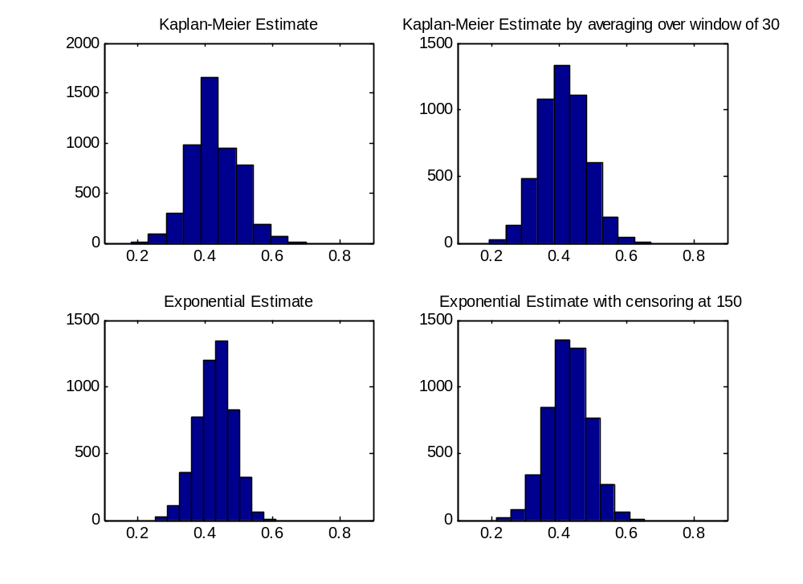

Table 1 lists the root mean squared prediction error (RMSPE), sample variance, and bias of the four predictors when the sample size is 50.

 | RMSPE | Sample Variance | Bias
Kaplan-Meier | 0.0711 | 0.0050 | -0.0020
Kaplan-Meier with window of 30 | 0.0709 | 0.0047 | -0.0185
Exponential | 0.0526 | 0.0027 | -0.0050
Exponential with censor | 0.0615 | 0.0038 | -0.0026

2, Sample Size = 15.

Figure 2 plots the estimated quantile from the four estimate
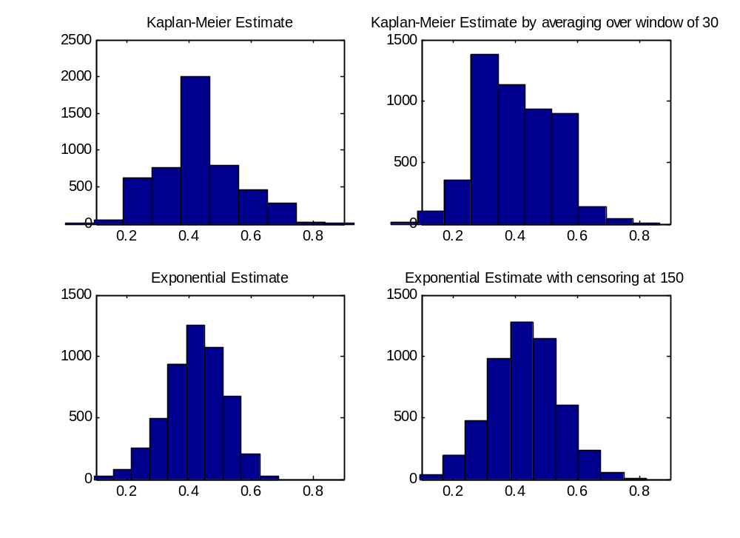

Table 2 lists the root mean squared prediction error (RMSPE), sample variance, and bias of the four predictors when the sample size is 15.

 | RMSPE | Sample Variance | Bias
Kaplan-Meier | 0.1264 | 0.0160 | 0.0017
Kaplan-Meier with window of 30 | 0.1278 | 0.0155 | -0.0296
Exponential | 0.0942 | 0.0087 | -0.0123
Exponential with censor | 0.1094 | 0.0120 | -0.0019

